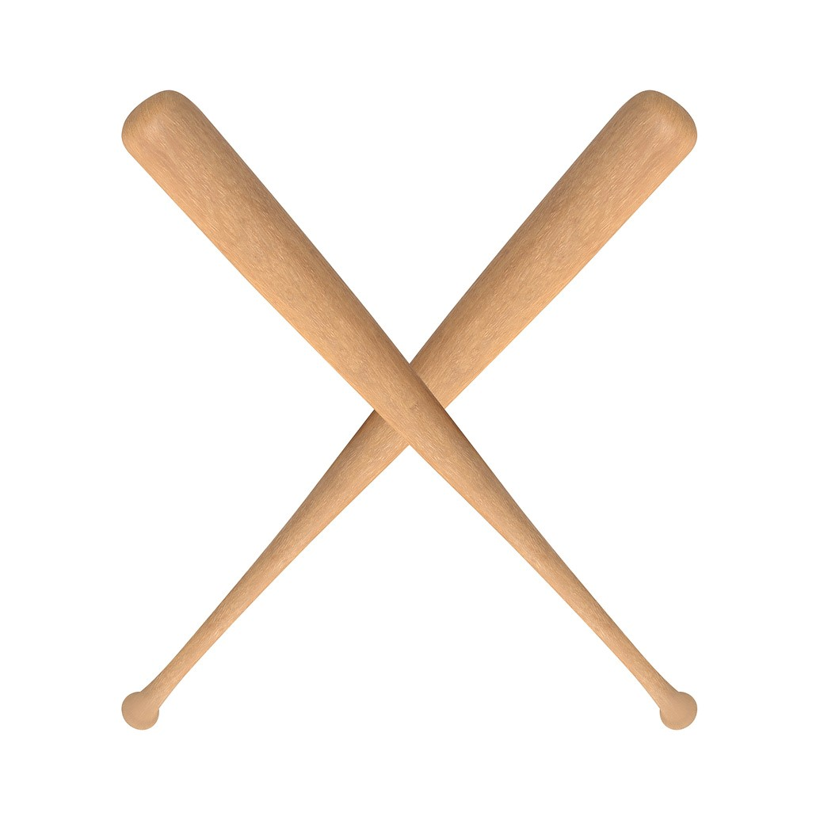

**2025**

**CHAMPS FITNESS WOOD BAT WEEKEND**

**FRIDAY AT ELLINGTON**

**3:00**

**JACKSON JV V ST PIUS X**

**5:00**

**JACKSON JV V EAST CARTER**

**ELLINGTON V ST PIUS X**

**7:00**

**AT LIBERTY**

**LIBERTY V DORA**

**11:00**

**1:00**

**DORA V WINONA**

**3:00**

**NAYLOR V WINONA**

**5:00**

**NAYLOR V PORTAGEVILLE**

**7:00**

**PORTAGEVILLE V LIBERTY**

**AT HOUSTON**

**3:00**

**MEXICO V HOUSTON**

**5:00**

**HOUSTON V HALFWAY**

**MEXICO V HALFWAY**

**7:00**

**2025 CHAMPS FITNESS WOOD BAT WEEKEND**

**SATURDAY AT HOUSTON**

**1:00**

**HOUSTON V ST PIUS X**

**3:00**

**MEXICO V NAYLOR**

**5:00**

**WINONA V HOUSTON**

**AT LIBERTY**

**10:00**

**MEXICO V ELLINGTON**

**12:00**

**MILLER V ELLINGTON**

**2:00**

**PORTAGEVILLE V MILLER**

**PORTAGEVILLE V JACKSON JV**

**4:00**

**6:00**

**HALFWAY V EAST CARTER**

**LIBERTY V EAST CARTER**

**8:00**